|  |  |  |  |
| --- | --- | --- | --- |
| Name:  Class: | ____________________________________  ________________ | | Date: ___________ |
|  | **Year 11 Essential Mathematics Unit 2**  SCORE:  /24 ___    **Mini Test 2.6 2018**  **Topic – Time and timetables**  ***Full working out MUST be shown to get full marks for each question.*** | | |
| **Total Time:** | 30 minutes |  | |
| **Weighting:** | 1% |
| **Equipment:** | To be provided by the student: Pen, pencil, ruler, scientific calculator,1 single sided page of A4 notes | | |

**Question 1**

Convert the following times below into different units. (6 marks)

1. ¼ century into years
2. 669 days into months
3. 90 days into years
4. 3.5 years into weeks
5. 367,200 seconds into days
6. 12,340 minutes into weeks

**Question 2**

Complete the following table. (5 marks)

|  |  |
| --- | --- |
| **24 hour time** | **12 hour time** |
| 0013 |  |
|  | 4:56 pm |
| 0934 |  |
| 2156 |  |
|  | 12:16pm |

**Question 3**

Marcus is looking forward to his favourite tv show which starts at 5:30pm. It is currently 2:55pm. How long does he need to wait? (2 marks)

**Question 4**

Bradley is picking his 3 friends Steve, Marsha and Beryl to go to a restaurant. It will take 11 minutes to get from Bradley’s house to Steve’s, 7 minutes to get from Steve’s house to Marsha’s, 6 minutes to get from Marsha’s to Beryl’s and then 4 minutes to get from Beryl’s house to the restaurant. What time does Bradley need to leave home if the restaurant booking is for 7:30pm? (4 marks)

**Question 5 [7 marks: 1, 1, 2, 2 & 1 mark]**

Mark needs to get from Roma Street Station in Brisbane to the Brisbane Domestic Airport as close to 1:30pm as he can. Below are two timetables - one for the train, the other for a bus:

Train timetable:

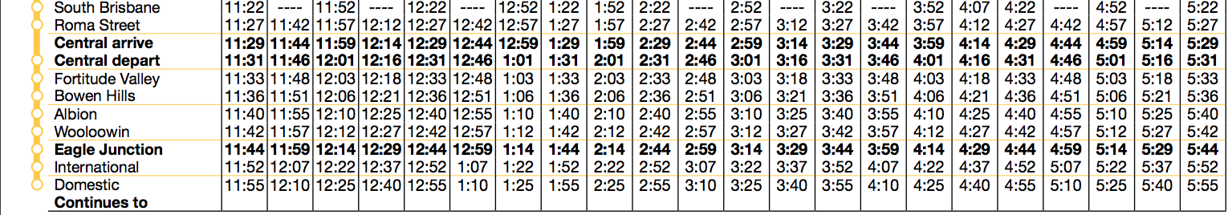

Bus timetable (Note: Brisbane Coach Terminal = Roma Street Station):



1. What time would you need to depart Roma Street to arrive at the airport in time for the train?
2. What time would you need to depart Roma Street to arrive at the airport in time for the bus?
3. How long will it take you to travel to the airport via the train? Show working out
4. How long will it take you to travel to the airport via the bus? Show working out
5. Which method of transport was faster?

**Question 6 [6 marks: 1, 1, 1, 1, 2 marks]**

Below is the tide chart for Fremantle from Monday 9th October to Sunday 15th October 2017, showing the 24-hour time and heights of low and high waters:

|  |  |
| --- | --- |
|  | Use the tide chart to answer the following questions:   1. On the tide chart, circle all the low tides, both time and heights. 2. How many high tides were there over the weekend? 3. If you wanted to leave Fremantle by boat on a high tide on the morning of Sunday 15th, what was the earliest time you could leave? 4. You were ready to come back onto land by 9pm on Sunday 15th, however you had to wait for a high tide. What was the earliest time you could bring the boat in? 5. How much time passed between the high tides on Sunday 15th October? |